* Build a model to predict chlorophyll
  + Model includes inflow, so predict inflow
    - What contributes to inflow
      * Runoff (precip based)
        + Modeled!
      * Baseflow
        + Hard to model without BVR’s inputs
      * BVR inputs
        + ? could be modeled probably
    - Find some other way to model streamflow?
      * Pressure at catwalk?
      * The forecast needs to be one day ahead
        + Can we use inflow(t) to predict inflow(t+1), similar to the chl AR model?
        + At the daily time step, the AR lag of 1 is pretty strong. If we were able to live stream inflow data could we use mean flow (t-1) to predict mean flow (t)???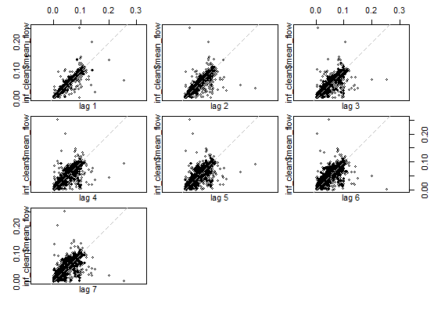
      * Other variables to look at in comparison to mean inflow?

